

Partial Differential Equations for Science and Engineering

Final Report

November 27, 2017

VARQUEZ, Alvin C.G.

14B00000

Contents

Problem 1 Diffusion Equation 2

A. Influence of Initial Condition 3

Program 3

Discussion 4

Problem 2 Burger’s Equation 5

Problem 3 1-D Advection Equation 6

Table of Figures

Figure 1 Initial condition set to 100 and only to regions aa 4

# Problem 1 Diffusion Equation

Construct a diffusion model for a 2-D heat plate with dimensions 100 m. by 100 m given the equation,



Discuss the following (add figures if necessary):

1. Influence of the initial condition. Test various initial conditions or distributions.
2. Investigate various boundary conditions:
   1. Dirichlet Boundary condition
   2. Neumann Boundary condition
3. Investigate what is the influence of by testing various values for *d*. What are the threshold values for *d*?
4. Show three time steps (start, middle, and almost steady-state). Steady-state means the variations with time are almost negligible.

## Influence of Initial Condition

### Program

1. **import** numpy as np
2. **import** matplotlib.pyplot as plt
3. **import** os
5. directory = os.path.dirname(os.path.realpath(__file__))
6. os.chdir(directory)
8. **def** get_value(it):
9. y = t
10. **return** t
12. **def** main():
13. t = np.arange(0.,10.,0.1)
14. x = np.linspace(0.,10.,num=100)
15. y = np.copy(x)
16. y[:] = 0.
17. icount = 1
18. **for** it **in** t:
19. **for** i **in** range(0,y.shape[0]):
20. y[i] = get_value(it)
21. plt.clf()
22. plt.plot(x,y)
23. plt.xlim(0,10)
24. plt.ylim(0,10)
25. plt.savefig("test_%03di.jpg"%(icount))
26. icount+=1
28. **if** __name__ == "__main__":
29. main()

### Discussion

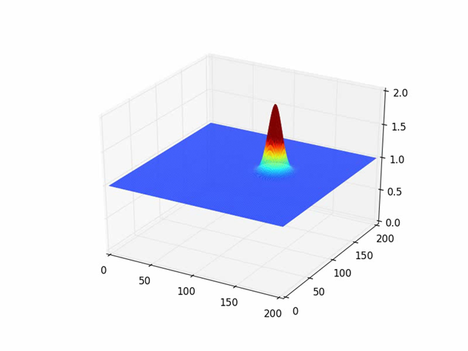

Figure 1 Initial condition set to 100 and only to regions aa

The initial condition plays an important role.. In this report, I investigated the following conditions… All blah blah… as shown in Figure 1

# Problem 2 Burger’s Equation

Using forward-in-time and backward-in-space for the 1st derivative, and centered difference for the 2nd derivative, construct a numerical model for the Burger’s equation. Decide on your own initial conditions and values for *v*.



Discuss the following (add figures if necessary):

1. Derive and write the discretization as an algebraic equation.
2. Investigate by modelling the differences when *a* (linear) is a constant and when *a* is *u* (non-linear) for a cyclic condition.
3. What happens when you set a Dirichlet boundary?
4. List potential applications for Burger’s equation. Properly write the reference (e.g. T.J. Chung, 2002).

# Problem 3 1-D Advection Equation

Given the following 1-dimensional equation



At *t*=0,



and with a cyclic boundary, discuss using the following parameters: . To answer the questions, decide on appropriate *C* values. Construct a model using (1) Upwind scheme, (2) Leith’s Method, (3) CIP Method, and (4) analytical solution.

1. Construct *f* plots along x for *t=*100, 300, 500, 700. Compare the results of each method and discuss the errors accompanied by each method.

Note: Make sure the code is constructed neatly. Place comments using “#” character.

## Initial Condition

Plot Function

1. **def** plot_line(n, folder): #Usual Plot Function
2. **global** model,f
3. plt.clf()
4. plt.cla()
5. plt.ylim(-.5,1.5)
6. plt.plot(model,f)
7. plt.text(80.,1.51,'t=%05.2f'%(n))
8. plt.text(10.,1.51,folder) #type of analysis
9. plt.savefig('%s/timestep_%04i.jpg'%(folder, n))

### Initial Value

1. f = np.zeros_like(model)
2. g = np.zeros_like(model)
3. f[40:60] = 1.
4. g[40], g[60] = 1./dx, -1./dx
5. dx = 1.
6. C = 0.9
7. u = 1.
8. dt = np.abs(C * dx/u)

## Functions

### Upwind scheme

1. **def** upwind(n, toplot=True):
2. **global** f
3. fn = f.copy()
4. usign = int(np.sign(u))
5. f = fn + C * (np.roll(fn,usign,0)-fn)
6. **if** toplot:
7. plot_line(n, 'upwind') #save file in folder 'upwind'

### Leith’s or Lax-Wendroff method

1. **def** lex(n, toplot=True):
2. **global** f
3. fn = f.copy()
4. c = fn
5. b = 1/(2*dx) * (np.roll(fn,-1,0) - np.roll(fn,1,0))
6. a = 1/(2*dx**2) * (np.roll(fn,-1,0) - 2*fn + np.roll(fn,1,0))
7. f = a * (u*dt)**2 - b*(u*dt) + c
8. **if** toplot:
9. plot_line(n, 'lex')

### CIP Method

1. **def** cip(n, toplot=True):
2. **global** f,g
3. fn = f.copy()
4. gn = g.copy()
5. usign = np.int(np.sign(u))
6. x_iiup = (-usign*dx) #x_iup - x_i sign deped on the sgn of stream
7. a = -2*(np.roll(fn,usign,0)-fn)/x_iiup**3   
   + (gn + np.roll(gn,usign,0))/x_iiup**2
8. b = -3*(-np.roll(fn,usign,0)+fn)/x_iiup**2   
   - (2*gn + np.roll(gn,usign,0))/x_iiup
9. eps = -u*dt
10. f = a * eps**3 + b*eps**2+gn*eps+fn
11. g = (3*a*eps**2+2*b*eps+gn)
12. **if** toplot:
13. plot_line(n, 'cip')

### Analytical Solution

1. fana = f.copy()
2. **def** ana(n, toplot=True):
3. **global** f
4. f = np.roll(fana,np.int(np.floor(u*n*dt/dx)%fana.shape[0])) #move function according to the stream
5. **if** toplot:
6. plot_line(n, 'ana')

Unfortunately, that x is discontinuous whichmay not be able to fit exactly byso we estimated the amount of blockto shift at any time spaceby using floor function

## Time Step

(500, 700 descriptions will be omitted and discussed once in Discussion)

### t = 100

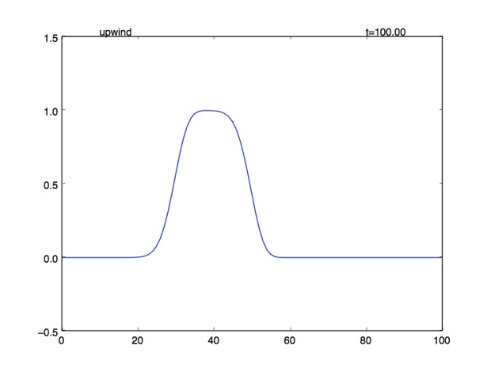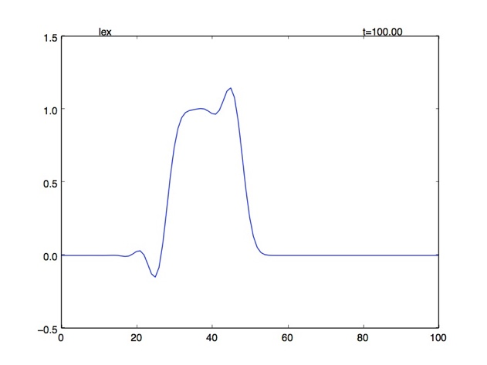

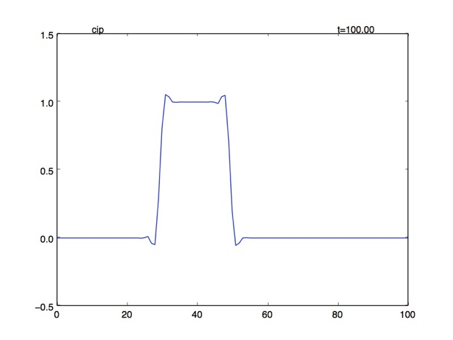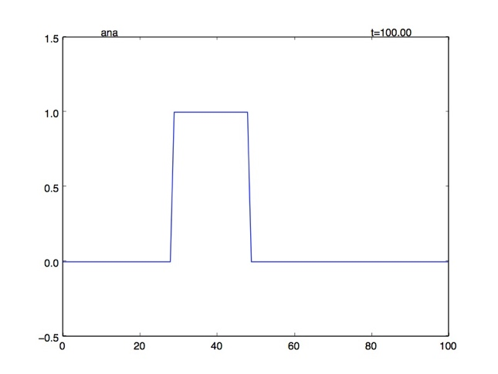

Upwind scheme:

The plot lost its shape and maximum altitude.

Leith’s method:

Some shooting appears at the border.

CIP method:

The shape is conserved with a small overshooting around the corner.

### t = 300

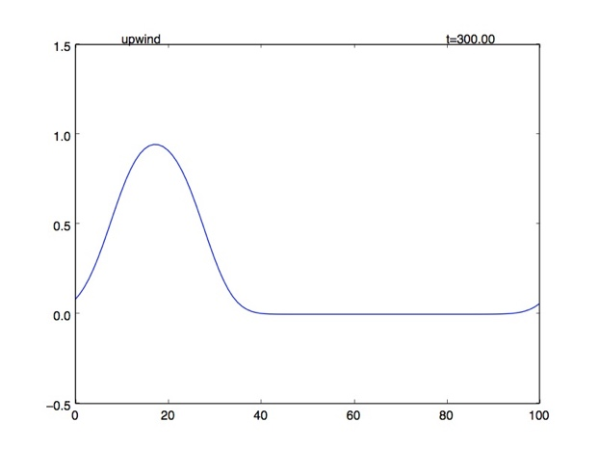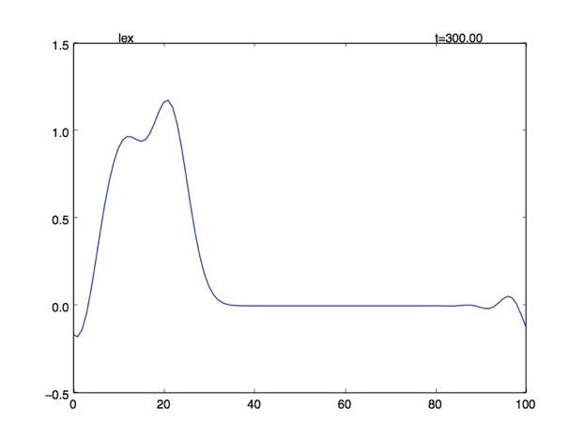

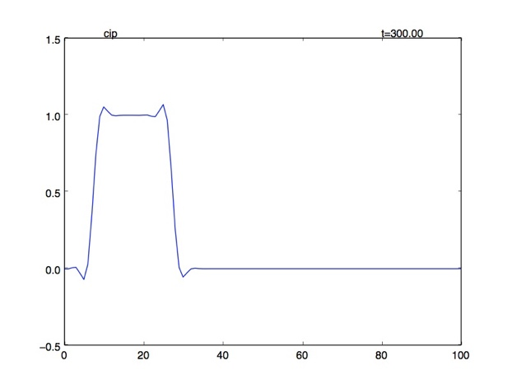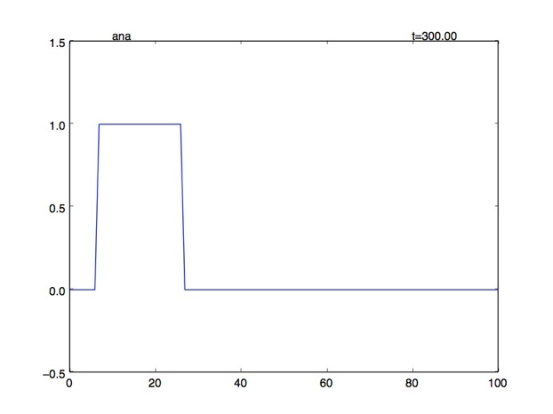

Upwind scheme:

kept losing its shape, maximum altitude and clearly became flat.

Leith’s method:

more wavy shootings appear at the corners though the altitude is not significantly changed.

CIP method:

No significant change to the shape, considerably stable.

### t = 500

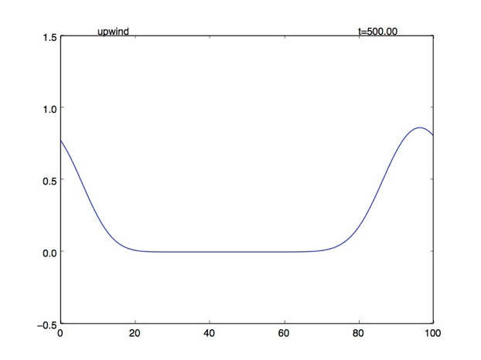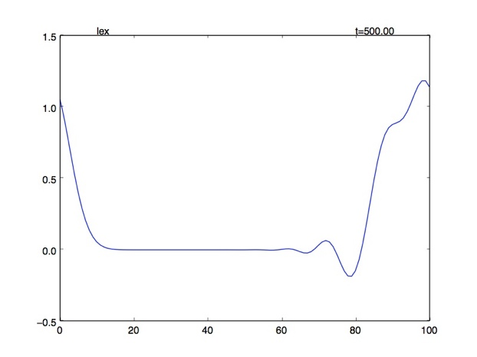

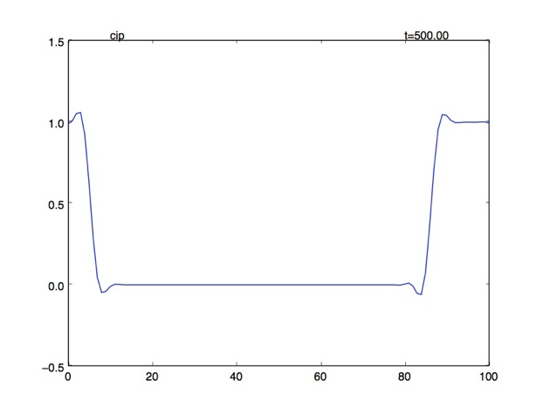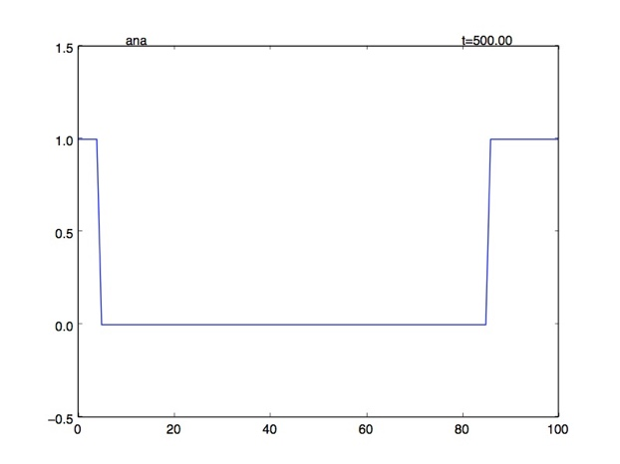

### t = 700

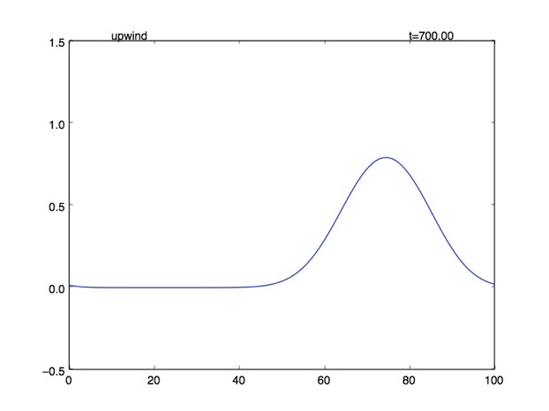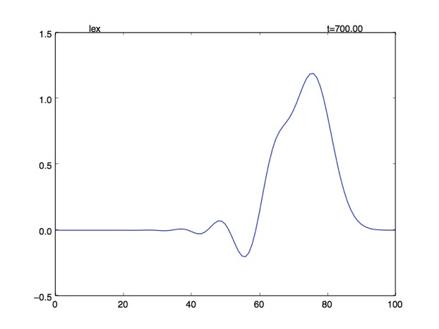

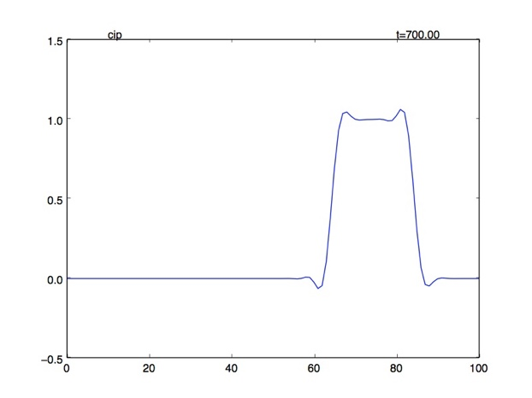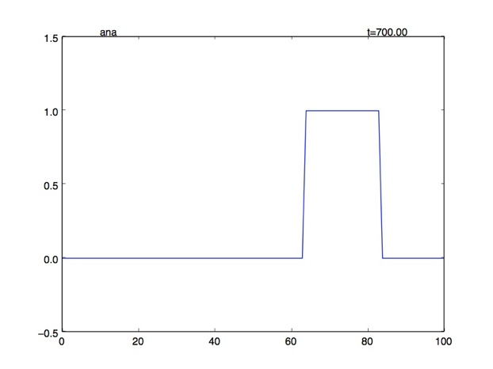

### Discussion

As the left figure, the upstream scheme dissipating started from the corners. Because of the linear interpolation, error appeared at the position with non-linear step. According to the figure, the red point’s value should be as same as the green point but it was estimated as the orange point. Analogously, the dissipation is similar to the landslide phenomenon.

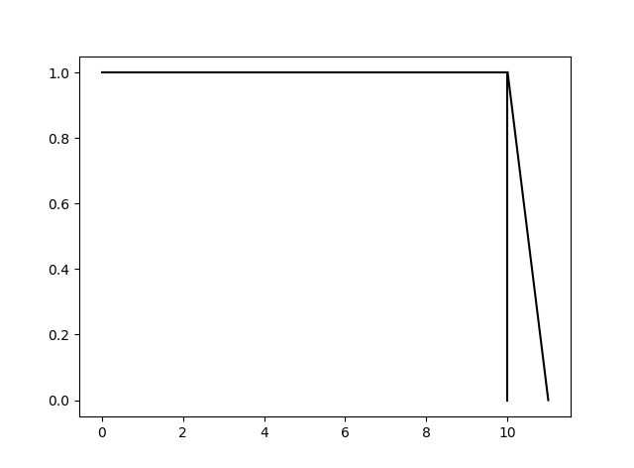

For the Lax-Wendroff Method, using 2nd order polynomial, did not appear any problem about dissipating but several wavy shootings occurred. This can be assumed from the property of Parabolic itself. Due to the existence of 2nd degree, the interpolation can be both convex or concave which make it not dissipated (overall estimation may work out better).

Furthermore, from the upwind scheme, assuming backward space and forward time.



And Taylor’s expansion at point 





Substitute in to the upwind scheme equation



Applying several algebra and calculus operation (detail in reference), eventually, we reached the final form



Which we can see that the dissipation in the upwind scheme caused by “diffusion term” from the truncation error. If , the diffusion term will lose its effect and the plot would dissipate slower.

For the 3rd order term, it is considered as “dispersion term”. For example, Korteweg–de Vries equation is a non-linear dispersion equation similar to 1-D advection equation but with 3rd order differential term. This effect can be seen in Lax-Wendroff Method.

As usual, which error the scheme will encounter depended on the leading term which has the largest influence. We can determine by the leading term of the truncation error, even for dissipation and odd for dispersion.

The truncation error of CIP method also leaded by even order as same as upwind scheme but suffer less dissipation because of third order estimation. However, eventually it should lose its amplitude.

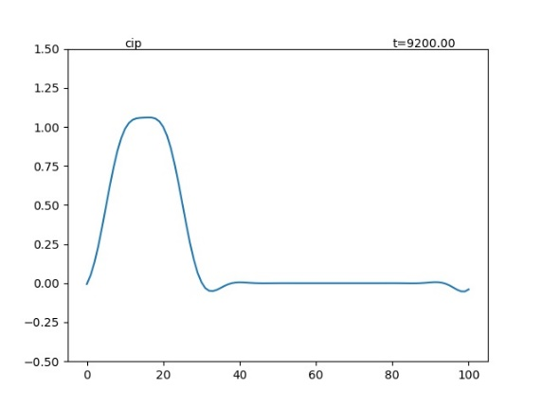

Figure 2 CIP dissipation

Ref:

<http://www.mathematik.uni-dortmund.de/~kuzmin/cfdintro/lecture10.pdf>

<http://twister.caps.ou.edu/CFD2007/Chapter3_3.pdf>

<https://en.wikipedia.org/wiki/Korteweg%E2%80%93de_Vries_equation>